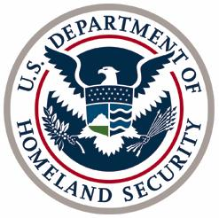
Homeland Security Advisory Council
Faith Based Security and Communications Subcommittee

Name Title, Organization
Bonnie Michelman Director of Police, Security and Outside Services at Massachusetts General Hospital and instructor at Northeastern University's College of Criminal Justice (Co-Chair)
Paul Goldenberg President and CEO, Cardinal Point Strategies (Co-Chair)
John Hodson Director of Church Security, North America Division, The Church of Jesus Christ of Latter-day Saints (Co-Vice Chair)
Salam Al-Marayati President, Muslim Public Affairs Council
Anju Bhargava Founder, Hindu American Seva Charities
Kim Burgo Senior Director for Disaster Services, Catholic Charities USA
Eric Fusfield Director of Legislative Affairs, B’nai B’rith International
Ronald Haddad Chief of Police, Dearborn Police Department
Mohamed Magid Executive Director, All Dulles Area Muslim Society (ADAMS)
Mary Marr Founder and President, Christian Emergency Network
Michael Masters Senior Vice President, The Soufan Group LLC
Levi Shemtov Executive Vice President, American Friends of Lubavitch
Suhag Shukla Executive Director & Legal Counsel, Hindu American Foundation
Dickson Skipper Director of Security, Billy Graham Evangelistic Association
Ali Soufan Chairman and Chief Executive Officer, The Soufan Group LLC
Siva Subramanian Founder, Sri Siva Vishnu Temple
Randy Vaughn Director of Office of Disaster Management, National Baptist Convention USA

